Total of 19 problems Please (see attachment (1)

Chapter 5
Problem 5.1

Sort descending this list by looked at the individual dollar contribution and total annual dollar contribution.
 | Product Bravo | Product Alpha | Product Charlie
Contribution | $3,000 | $2,500 | $1,750
Annual sales | 1,500 units | 1,000 units | 3,500 units
Life cycle | Growth | Introduction | Decline
Assume the graph looked like this

Sales
Contribution
Introduction
Growth
Decline

Look at the table and graph, product Charlie at decline stage of life cycle and know this product will be end in the certain period from now. The products are not up to date, not suitable for this era (technology era). Thus, the customers turn to the competitor products because they come out with new and fresh idea. Therefore, this product must produce in the small quantity while it has the demand and also as organization responsibility for certain people that can’t adapt new products. Besides that the organization must plan to terminate offering. For product Alpha, it seat at the introduction of life cycle, so for this product, it didn’t have any problem to produce in a large quantity if it get the good response from customers but if the response from customer is bad or not well, produce the product in the small quantity. Because, these products are new in market, not all customers know about it and also still need some changes. Additionally in this stage, should to do more on research, product development, process modification and enhancement and supplier development. In addition, the advertising to introduce or promote this product to customer must do it well. Furthermore, the life cycle of product Bravo is growth. In this stage, the product is become stable, because the customers already know about the products. Thus, by add more on quantities to accommodate the raise in product demand. Last but not least, the advertising also must do for create the demand.

Problem 5.18
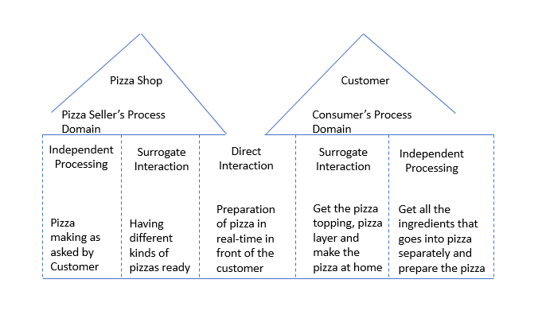
Chapter 5
Supplement: Sustainability in the Supply Chain

S5.4
Vehicle purchase cost $17,000
Vehicle operating cost per mile $0.12
Useful life of vehicle 15
Miles per year 14,000
Miles per gallon 32
Average fuel price per gallon $3.75
Total Life Cycle Cost = Cost of Vehicle + Life Cycle Cost of Fuel + Life Cycle Operating Cost
=$17,000 +(14,000(miles/years)/32(miles/gallon)) ($3.75 /gallon )(15 years)+(14,000 (miles/year)($0.12/mile)(15 years)
=$17,000+$24,609 +$25,200
= $66,809

S5.5
Vehicle purchase cost $19,000
Vehicle operating cost per mile $0.09
Useful life of vehicle 15
Miles per year 14,000
Miles per gallon 35
Average fuel price per gallon $3.75
Total Cost of Hybrid vehicle = Total Cost of Alternative vehicle
Vehicle Purchase Cost + [(Average Fuel Price per Gallon/ Miles per Gallon) + Vehicle Operating Cost per Mile] * (M Miles) = Vehicle Purchase Cost + [(Average Fuel Price per Gallon/ Miles per Gallon) + Vehicle Operating Cost per Mile) * (M Miles)
Let M be the crossover point, in miles. Set the equations to equal each other and solve for M:
$17,000+((3.75 ($/gallon)/32(miles/gallon))+0.12($/mile)) (M miles) =$19,000+((3.75 ($/gallon)/35(miles/gallon))+0.09($/mile)) (M miles)
$17,000+0.237($/mile) (M)=$19,000+(0.197($/mile)(M)
(0.04 ($/mile))(M)=$2,000
M=$2,000/(0.04($/mile))=50,000 miles

Chapter 6: Managing Quality
Problem 6.3

Reason Code | Reason for Poor Grade | Frequency
A | Insufficient Time to complete | 15
B | Late arrival to exam | 7
C | Difficulty understanding material | 25
D | Insufficient preparation time | 2
E | Studied wrong material | 2
F | Distraction in exam room | 9
G | Calculator batteries died during exam | 1
H | Forgot exam was scheduled | 3
J | Felt ill during exam | 4
 | Total frequency | 68

Pareto’s Analysis
Reason description | Frequency | % Frequency | % Cumulative Frequency
Difficulty… | 25 | 37% | 37%
Insufficient ... | 15 | 22% | 59%
Distraction | 9 | 13% | 72%
Late arrival to | 7 | 10% | 82%
Felt ill … | 4 | 6% | 88%
Forgot exam ... | 3 | 4% | 93%
Insufficient … | 2 | 3% | 96%
Studied … | 2 | 3% | 99%
Calculator ,,, | 1 | 1% | 100%
 | 68

Problem 6.6 Develop a flowchart (as in Figure 6.6e and Example 2}

Partial flowchart for planning a party There are many forms and symbols used in flowcharts.

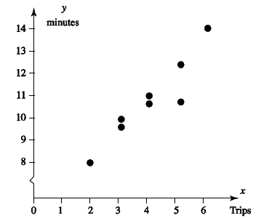

Chapter 6
Sustainability in the Supply Chain

Problem S6.1
14+3(.0167)=14.05
14-3(.0167)= 13.95

Problem S6.5

UCL_{x}=705+0.0308*6=706.848 cc³
LCL_{x}=705-0.308*6=703.152 cc³
UCL_{R}=1.777*6=10.662 cc³
LCL_{R}=0.223*6=1.338 cc³

Process Strategy (3 Problems)

Chapter 7 problems
Problem 7.5
a)

b)
let x = total quantity ordered
Y1 = 4 * x (Buy)
Y2 = 15000 + 1.82 * x (Make)
no difference when
Y1 = Y2
so, 4x = 15000 + 1.82x
x = 15000/2.18
= 6880.7 units

Problem 7.7
 | Total Rooms |  | 18250
 | Tim's Cost @ $12.50 |  | $2,28,125.00
 | Fixed Costs |  | $61,000.00
 | Tim's Total Expense |  | $2,89,125.00
 | Duffy Maid Service
 | @ 18.50 + $25,000 |  | $3,62,625.00
 | Difference |  | $73,500.00 | 25.42%
Tim should NOT outsource the daily room cleanup as the cost is $73,500 or 25.42% higher when outsourcing.

Problem 7.11
a. Cross over point or Indifference point = Difference in Fixed cost / Difference in variable cost
Total Cost of Machine A= 75,000+16Q
Total Cost Of Machine B= 60,000+20Q
60,000+20Q=75,000+16Q
20Q-16Q=75,000-60,000
4Q=15,000
Q=15,000/4
Q= 3,750 Units.
The Crossover point is 3,750 units.
b. Beyond 3,750 Units of production and sale.
c) Below 3,750 Units of production and sale

Supplement Capacity and Constraint Management (3 Problems)

Problem S7.21
Price (P)=$8/ unit
Variable cost(V)=$4/ unit
Fixed cost(F)=$50,000
a. Break-even in units is given by
BEP_{x}=F/P-V=50,000/(8-4)=50,000/4=12,500 units
b. Break-even in dollars is given by
BEP$=f/(1-V/P)=50,000/(1-4/8)=50,000/1-0.50=$100,000
d. Profit is given by
Profit=Volume*Contribution-Fixed cost
=(8-4)*100,000-50,000
=400,000-50,000
=$350,000

Problem S7.23

Option A : Stay as is
Option B: Add new equipment.
Unit * (Price-V)-F=Profit
Profit_{A}=30,000*(1.00-0.50)-14,000=$1,000
Profit_{B}=50,000*(1.00-0.60)-20,000=$0
Therefore, the company should stay with the current equipment.

Problem S7.25
Where F=$37,500 V=$1.75 P=2.50
a. Break-even quantity for the manual process in units:
=F/P-V=37,500/(2.50-1.75)=50,000 bags
b. Revenue at the break-even quality for the manual process:
50,000*2.50=$125,000 and
BEP$=37,500/1-V/P=37,500/1-(1.75/2.50)=$125,000
c. Break-even quality for the mechanized process: where F=75,000, P=2.50, V=1.25
BEP_{x}=75,000/(2.50-1.25)=60,000 bags
d. Revenue at the break-even quality for the mechanized process:
60,000*2.50=$150,000
Or
BEP$=75,000/1-(1.25/2.50)=$150,000
e) Monthly profit or loss of the manual process if they expect to sell 60,000 bags of lettuce per month:
Profit = 2.50(60,000) – 1.75(60,000) – 37,500 = $7,500

(f) Monthly profit or loss of the mechanized process if they expect to sell 60,000 bags of lettuce per month
2.50(60,000) – 1.25(60,000) – 75,000
= 0.0 (break-even)
(g) They should be indifferent to the process selected at 75,000 bags.
.75X- 37,500=1.25X -75,000
37,500 =.5X
75,000=X

(h) The manual process should be preferred over the mechanized process below 75,000 bags. The mechanized process should be preferred over the manual process above 75,000 bags
BEP$=3800/0.501=$7,584.83
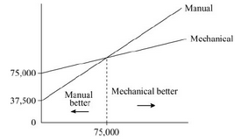

Problem 8.5

FACTOR | WEIGHT | MAITLAND | BAPTIST CHURCH | NORTHSIDE MALL
Space | .30 | 60 | 70 | 80
Costs | .25 | 40 | 80 | 30
Traffic density | .20 | 50 | 80 | 60
Neighborhood income | .15 | 50 | 70 | 40
Zoning laws | .10 | 80 | 20 | 90

a)

Factor | Weight | Score | Maitland  Weighted Score | Score | Baptist Church  Weighted score | Score | Northside Mall  Weighted score
Space | .30 | 60 | 18 | 70 | 21 | 80 | 24
Costs | .25 | 40 | 10 | 80 | 20 | 30 | 7.5
Traffic density | .20 | 50 | 10 | 80 | 16 | 60 | 12
Neighborhood income | .15 | 50 | 7.5 | 70 | 10.5 | 40 | 6
Zoning laws | .10 | 80 | 8 | 20 | 2 | 90 | 9
Total score |  |  | 53.5 |  | 69.5 |  | 58.5

Subway should open the new restaurant at Baptist Church because it has the highest score of 69.5.

b)

Factor | Weight | Score | Maitland  Weighted Score | Score | Baptist Church  Weighted score | Score | Northside Mall  Weighted score
Space | .20 | 60 | 12 | 70 | 14 | 80 | 16
Costs | .25 | 40 | 10 | 80 | 20 | 30 | 7.5
Traffic density | .30 | 50 | 15 | 80 | 24 | 60 | 18
Neighborhood income | .15 | 50 | 7.5 | 70 | 10.5 | 40 | 6
Zoning laws | .10 | 80 | 8 | 20 | 2 | 90 | 9
Total score |  |  | 52.5 |  | 70.5 |  | 56.5

If the weights for Space and Traffic density are reversed, Baptist Church still gets the highest score.

Problem 8.7

FACTOR | WEIGHT | PHILADELPHIA | NEW YORK
Customer convenience | .25 | 70 | 80
Bank accessibility | .20 | 40 | 90
Computer support | .20 | 85 | 75
Rental costs | .15 | 90 | 55
Labor costs | .10 | 80 | 50
Taxes | .10 | 90 | 50

Factor | Philadelphia | New York
Customer convenience | (.25)(70) = 17.5 | (.25)(80) = 20
Bank accessibility | (.20)(40) = 8 | (.20)(90) = 18
Computer support | (.20)(85) = 17 | (.20)(75) = 15
Rental costs | (.15)(90) = 13.5 | (.15)(55) = 8.25
Labor costs | (.10)(80) = 8 | (.10)(50) = 5
Taxes | (.10)(90) = 9 | (.10)(50) = 5
Totals | 73 | 71.25

Northeastern should locate in Philadelphia because it got a higher score, which is a better score.

Problem 8.9

a)

 | LOCATION
FACTOR | WEIGHT | AKRON,OH | Weigted Score | BILOXI, MS | Weigted Score | CARTHAGE,TX | Weigted Score | DENVER, CO | Weigted Score
Labor Ability | 0.15 | 90 | 13.5 | 80 | 12 | 90 | 13.5 | 80 | 12
Technical School quality | 0.10 | 95 | 9.5 | 75 | 7.5 | 65 | 6.5 | 85 | 8.5
Operating Cost | 0.30 | 80 | 24 | 85 | 25.5 | 95 | 28.5 | 85 | 25.5
Land and Construction cost | 0.15 | 60 | 9 | 80 | 12 | 90 | 13.5 | 70 | 10.5
Industrial Incentives | 0.20 | 90 | 18 | 75 | 15 | 85 | 17 | 60 | 12
Labor Cost | 0.10 | 75 | 7.5 | 80 | 8 | 85 | 8.5 | 75 | 7.5
Total | 1 |  | 81.5 |  | 80 |  | 87.5 |  | 76

b) Which site would you choose?
I would choose as location: Carthage, Texas, because it has a bigger weighted score than the others locations.
c)Would you reach the same conclusion if the weights for operating cost and labor cost were reversed? Recompute as necessary and explain.
 | LOCATION
FACTOR | WEIGHT | AKRON,  OH | Weigted  Score | BILOXI, MS | Weigted  Score | CARTHAGE,  TX | Weigted  Score | DENVER,  CO | Weigted Score
Labor Ability | 0.15 | 90 | 13.5 | 80 | 12 | 90 | 13.5 | 80 | 12
Technical School quality | 0.1 | 95 | 9.5 | 75 | 7.5 | 65 | 6.5 | 85 | 8.5
Operating Cost | 0.1 | 80 | 8 | 85 | 8.5 | 95 | 9.5 | 85 | 8.5
Land and Construction cost | 0.15 | 60 | 9 | 80 | 12 | 90 | 13.5 | 70 | 10.5
Industrial Incentives | 0.2 | 90 | 18 | 75 | 15 | 85 | 17 | 60 | 12
Labor Cost | 0.3 | 75 | 22.5 | 80 | 24 | 85 | 25.5 | 75 | 22.5
Total | 1 |  | 80.5 |  | 79 |  | 85.5 |  | 74

After reversing Labor Cos and Operating Cost, Carthage, Texas still being the best location for Cook Controls with an average weight of 85.5

Problem 9.11
a) Takt time = time taken/units produced= 420/250= 1.68 mins per unit
b) Standard time for one unit= 1.1+1.1+1.7+3.1+1.0= 8 mins
No. of workers required to complete the unit in takt time= 8/1.68= 4.76~5
Employees to be cross trained for new cell= 5
c) Special consideration may be warranted for the cleaning operation because it takes the longest operational time. Out of 6 employees two employees should be provided for cleaning operation.

Problem 9.15
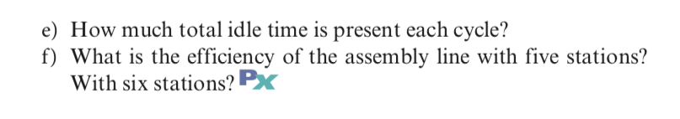
a)
Answer A:-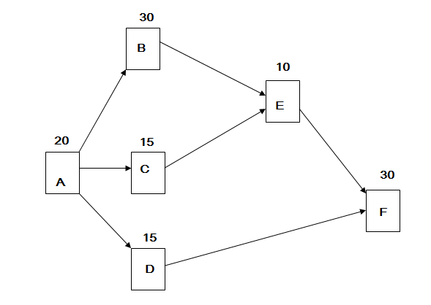
b)
r = 4,800 hour/week
r = 4,800/40=120 units/hour
Cycle time = 1min/60sec = 1min/unit = 60 sec/unit
c)
TM = 120 sec /60 sec= 2 stations
Answer D:-
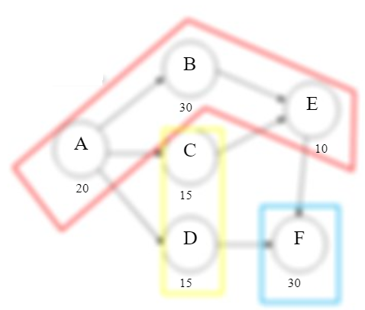
Station Work elements assigned
1 A, B, E
2 C, D
3 F
Answer E:-
Station Work elements assigned Cumulative Time Idle time c = 60 sec
1 A, B, E 60 0
2 C, D 30 30
3 F 30 30
Total idle time = 30 + 30 = 60 sec
Answer f:- 5 stations:Efficiency= [ 120 sec/ 5(60) ] X 100 = 0.4 X 100 = 40%
6 stations:Efficiency= [ 120 sec/ 6(60) ] X 100 = 0.333 X 100 = 33.33 %

